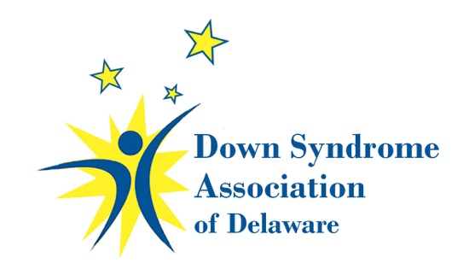
2019 DSA of Delaware Board of Directors Nominations
The nominations committee is accepting nominations for the election of the DSA of DE Board of Directors being held on April 13, 2019. The office of President shall be limited to parents of individuals with Down syndrome; all other open positions shall be open to any interested persons. At-Large Directors will assist the president as needed and serve as chair of one or more committees. Committee Chairs are determined at the first board meeting after elections. Board meetings are held once per month, normally the first Monday of the month. Committee meetings will be held at the discretion of the Committee Chair. All positions are a two year commitment. All nominees must agree to and sign the Board Member Responsibilities Agreement that follows.
If you are interested in running for a board position please check the appropriate position you are interested in and complete requested information. New members of the board are strongly encouraged to join as an at-large director prior to running for an executive position.
- President
- Secretary
- Self Advocates (2positions open)
- At-Large Director (2 positions open)
Name: ______________________________________
Home Phone:_________________________ Cell Phone: __________________________
Address:__________________________________________City __________________ST______ Zip _________
Email Address:___________________________________
If related to someone with DS:
Relationship__________________ Name________________________________ DOB______________
Bio: This will appear on the ballot and will be used in the “About Us” section of the website to introduce our board members to website visitors.
________________________________________________________________________________________________________________________________________________________________________________________________________________________________________________________________________________________________________________________________________________________________________________________________________________________________________________________________________________________________________________________________________________________________________________________________________________________________________________________________________________________________________________________________________________________________________
Availability
Please indicate your ability to attend/participate in the following:
_____ Board Meetings 1st Monday monthly 6:00pm-9:00pm 48 hours/year
_____ Committee Meetings as scheduled by committee chairs 1-2 hours/month
_____ Strategic Planning (reviewed/conducted annually) 6-8 hours /year
_____ Attend DSA of DE -sponsored events 20-30 hours/year

Background

Please state your motivation for becoming involved with DSA of DE:

Please list your strengths, knowledge, and experience you would bring to the board:
(Please include any areas of expertise such as financial management, marketing/public relations, special program focus like education, health, public policy), technology, law, administration/management, etc)

Committee Preference
Please contact President for more detailed descriptions if needed to make selection (additional task forces may be assigned throughout the year.)

_____ Buddy Walk ________ Run for the Buds
_____ AI duPont Clinic ________ Finance/Investment
_____ Outreach Committee ________ Government/Advocacy
_____ Social Events ________ Teens/Adults
_____ Education Committee _________Website/IT
_____ Other:______________

Summary of DSA of DE Board of Directors
Four Executive Officers:
- President: Serves as the official representative and is responsible for the overall operation of the organization and its strategic plan. Serve on or chair one or more committees.
- Vice President: Presides in the absence of the president. Communicates to membership local, national, medical and legislative issues pertinent to our organization. Serve on or chair one or more committees.
- Secretary: Responsible for correspondences, mailings. Assists in maintaining membership database. Serve on or chair one or more committees.
- Treasurer: Receive and disburse funds. Maintain financial records. Prepare monthly report. Prepare a year-end financial report. Serve on or chair one or more committees.

2 Self-Advocates: Each will assist the president and serve on a committee
Up to 10 At-Large Directors: Assist the president as needed and serve as chair of one or more committees. One director position is reserved for a representative from our southern connections

**All terms are two years, with the positions of Vice-President and Treasurer elected in even years, and Secretary and the President elected in odd years. In any given year, one self-advocate and half of the At-Large Directors shall be elected. The offices of President and Vice-President and Outreach Committee Chair shall be limited to parents of individuals with Down syndrome; all other offices and positions shall be open to any interested persons. The sitting President & Secretary will be re-running for their second terms this year.
Summary of Committees

Website and IT Committee – Website Management, Membership Data Base, Updating website content, E-news

Parent Education Committee - Plan and Implement Monthly Parent Education Meetings (Example of Topics: Nutrition, DS Clinic, Potty Training, Behavior Strategies, etc.), Arrange for name tags, signage and promotional materials at all events. Plan and implement other Education Workshops.
Maintain a Lending Library and comprehensive resource information

Social Events Committee - Plan and schedule Annual DSA of Delaware Events (Easter Egg Hunt, Children’s Holiday Party, Adult Holiday Party, Blue/Gold Tailgate Party, Summer Pool Party or Beach Bash, Fall Hayride and Bonfire. Work with Teen and Adult Chair on combined events. Plan any other Special Social Event Gatherings (examples: Young Academy Cooking Social, Train Ride and Picnic, Play date at Can DO! Playground, etc.,) Send out Event details to Public Relations Committee for Newsletters and Website.

Teen and Adult Committee – Plan social and educational events appropriate to the teen and adult population and their families. Coordinate with Social Events Committee on combined events. Send out Event details to Public Relations Committee for Newsletters and Website.

Fundraising Committee – Facilitate all DSA Fundraising events (examples: Buddy Walk, Golf Fundraiser, etc.)

Outreach Committee - Create and gather materials for New Parent Information Packets, Contacts new families to arrange meeting and delivery of packet, Contact Social Workers at all area hospitals to introduce DSA and offer information packets, Liaison at A.I. DuPont Hospital Down Syndrome Clinic - currently held the 2nd and 4th Tuesday of every month, Create and update New Member spreadsheet monthly.

Volunteer Committee – Obtain Volunteers to cover all DSA of DE Events as needed, Update our information on VolunteerMatch.com for upcoming events, Contact Local Community organizations to utilize their membership for Volunteering. (Examples: The Rotary Club, Lions Club, Moose Lodge, Sorority and Fraternities, etc.)

Professional Education Committee - Formulate and implement a strategy for the education of best practices for teachers, therapists, medical professionals, and others who work with individuals with DS.
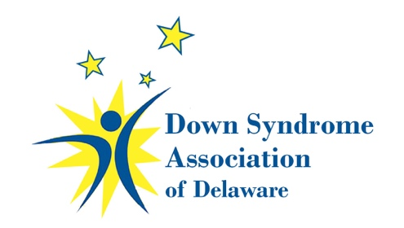
Board Member Responsibilities
The DSA of Delaware understands that Board Members have many personal and professional responsibilities. The list below is not exhaustive but should serve as a good example of the commitment required to serve on the DSA of Delaware Board of Directors. Along with our people, our reputation is one of the DSA of Delaware’s most valuable assets. It takes years to build a strong reputation, and each of us must do our part to protect it every day. This includes understanding the types of activities that may expose our organization to reputational risk. Members of our Board of Directors are especially responsible for ensuring that their actions do not compromise the reputation of our organization. These actions include, but are not limited to comments on social media sites and other internet portals. Reputation risk oversight is the obligation of the Governance Committee and the Executive Board of Directors.
General Duties
- Serve as chair of one or more committees
  - Submit and adhere to a budget for the committee.
  - Recruit committee members and hold committee meetings.

- Attendance at monthly board meetings is mandatory.
- Full Board meetings are held on the first Monday of each month from 6:00 – 9:00, usually at conference room at AI DuPont hospital. In the event that the first Monday is a holiday, the meeting will take place on the second Monday or as scheduled by the president.
- Be an active meeting participant - contribute information and express a point of view, based on your experience and knowledge.
- Board members should not discuss the confidential proceedings of the board outside of the board meeting.
- If you are unable to attend please contact the president in advance.

- Volunteer in some capacity for the Buddy Walk and Run for the Buds Fundraising events.

- Be an active participant in our social and educational events and monthly parent meetings.

- Represent the DSA of Delaware at events hosted by other organizations.

- Act as an ambassador of DSA OF DE to continually enhance our public image.

- Speak on behalf of the DSA OF DE to lay audiences.

- Respond to e-mails in a timely fashion.

- Board members will not use part of the organization for their personal advantage or that of their family or friends.

I have reviewed the responsibilities above and agree to make the commitment required to be a member of the Board of Directors of the Down Syndrome Association of Delaware.
Signature:___________________________________________Date:___________________

