Delaware Ages 21 and Older Checklist-
Intellectual or Developmental Disability

This checklist was compiled after several Delaware- based nonprofit organizational leaders saw individuals with intellectual and developmental disabilities (IDD) and their families struggling to navigate services and community resources, especially at ages 21 and older. The main goal of this checklist is to provide a condensed informational resource for various aspects of the individual’s life so applicable elements can be explored further.

Please note this is not all encompassing but serves to provide self-advocates, parents and guardians a starting point.

This list would be helpful to you if:

- Your family moved or is moving to Delaware and has a family member with IDD who is or will be soon be age 21
- You are the caregiver or sibling of an individual with IDD who is or will soon be age 21
- You are the parent or caregiver of an individual with IDD who is or will soon be age 21
- You are an individual with IDD

Partners in Checklist Development:

Lauren Camp Gates, Executive Director, Down Syndrome Association of Delaware
Ed Gootzait, Board Member, Down Syndrome Association of Delaware
Verna Hensley, Vice President of Public Affairs, Easterseals
Nancy Ranalli, Director of Community Outreach & Assistive Technology, Easterseals
Maria Pippidis, County Director and Extension Educator, Family and Consumer Sciences, UD Cooperative Extension
Jennifer Tozer, Manager of Family Engagement, Delaware Department of Healthy & Social Services (DHSS)
Susannah Eaton-Ryan, Director of Employment and Outreach, The Arc of Delaware
Annalisa Ekbladh, Director, Policy & Family Services, Autism Delaware

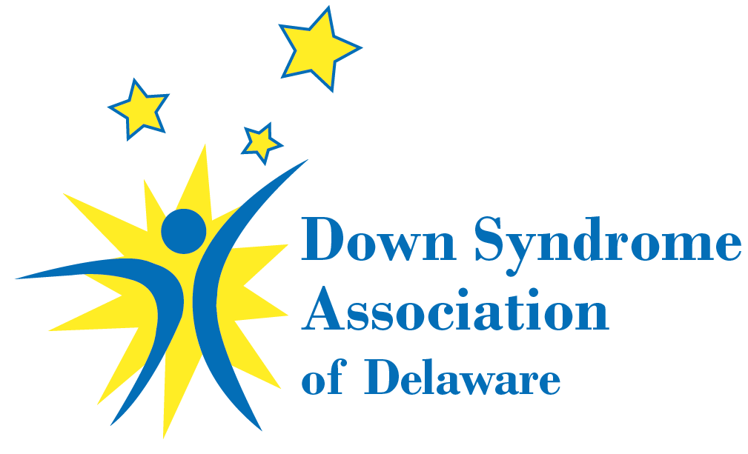 |  | 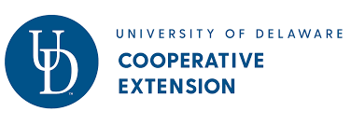
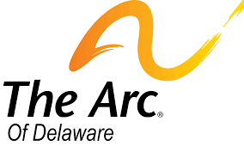 | 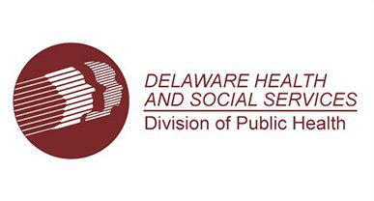
Priorities (Do these things first):

- Apply to Division of Developmental Disabilities Services (DDDS) – If you have a child aged 3 through 12 that you believe has an intellectual or developmental disability and you plan on applying to DDDS for services in the future, you can submit a request to the Division to review your child’s information to possibly determine Presumptive Eligibility for Respite Services. Presumptive Eligibility ends at age 13 and individuals must complete a DDDS to access Respite services and other services (employment services, behavioral, benefits counseling, etc.). Because the application process can be lengthy and individuals are eligible at 13, it is advisable to explore eligibility at that time.
  - A Community Navigator is provided to you, through The Columbus Organization, once you are approved and they connect you to community resources. The Division of Developmental Disabilities Services has contracted with The Columbus Organization to provide Targeted Case Management with the goal of supporting individuals in the context of their families. A Community Navigator supports by working with the family in developing a Person-Centered Plans (PCP) that captures the needs and goals of the individual and family unit; helping to identify community resources for unmet needs; assisting families to learn about eligibility-based services. The Community Navigator is the individual’s key contact with the Division of Developmental Disabilities.
- Obtain an DMV Identification Card
- Learn more about Medicaid – consider if it is right for you or the individual, Medicaid provides access to Home & Community based services such as a day program or employment supports, this is also a low-income medical insurance for families that meet that criteria

Health and Medical Care and State Services

- Consider Center for Special Health Care Needs at Christiana is the only center in the greater Delaware area dedicated to providing primary care for adults ages 18 and older with complex medical and social conditions that originated in childhood.
- Consider Practice without Pressure specialized healthcare for people with disabilities (focuses on fears)
- Understand how your Medicare benefits would affect and support the individual with the disability
- Understand difference between the Division of Medicaid and Medicare Long Term Care Support and Services Waiver (LTSS) Vs. the DDDS Lifespan Waiver
- Understand resources for mental Health- such as The Division of Substance Abuse and Mental Health
- Explore the Division of Services for Aging of Adults with Disabilities
- Issues understanding insurance options? Visit HealthInsurance4U offered by the University of Delaware Cooperative Extension

Considerations: Are your physicians covered under the insurances you are using?

Assistive Technology

- Explore UD Assistive Technology find and try tools that support learning, communication, personal care, employment and leisure pursuits (known as DATI)
- Easterseals Resource and Technology Demonstration Center

Considerations: If you are exploring post-secondary education, remember that by the American with Disabilities Act there will be student services available for supports

Employment

- Division of Vocational Rehabilitation (DVR) this is a branch of the Department of Labor and is federally funded. It helps individuals with disabilities secure employment.
- Division of Visually Impaired (DVI) has a Vocation Rehab department
- Learn more about the Workforce Innovation and Opportunity Act (WIOA)
- DDDS/DVI/DSAAPD manages Pathways to Employment (eligible with Medicaid, 14-25 years old) – provides Employment Navigator, internship opportunities, workplace support, other employment supports as well

Considerations: remember that your plan and goals drive the services you utilize.

Housing

- Apply to DDDS (see above) – funds residential services through their Home and Community based waiver, the Lifespan Waiver, you have to meet the level of care to receive any of the services through the waiver
- Housing and Urban Development
- Section 8 – Kent and Sussex counites, reduced rent properties
- Delaware State Housing Authority (several housing authorities- local such as Wilmington, Newark, Dover) – information on low income housing, first-time homebuyer’s assistance
- United Cerebral Palsy of Delaware- has accessible housing options available
- Freedom Center for Independent Living – housing option and resource network in Middletown DES
- Independent Resources Inc. – nonresidential organization but works to provide resources and make connections so individuals can live their best life
- National Alliance on Mental Illness housing

Social and Relationships

- Planned Parenthood – offers disability programs and workshops for caregivers and self-advocates.
- Special Olympics – provides sports programs at no cost to individuals ages 2 and older (no upper age limit) all throughout the state
- Best Buddies – friendship program for those with intellectual and developmental disabilities
- Expanding Options: www.expandingoptions.org Is a parent led non-profit organization that was founded to help create social opportunities for their adult children on the Autism Spectrum. The Organization recognizes themselves as two groups, Caregivers and Adult Members, and try to coordinate meaningful content and speakers for each group at routine monthly meetings. The group welcomes anyone, 18 or older, to participate in monthly meetings and routine social outings. It is important to know that parent involvement may be necessary as they do not provide supervision/paid staff.
- Federal Park Pass is a free, lifetime pass available to United States citizens or permanent residents, regardless of age, that have a permanent disability that can be used at over 2,000 Federal recreation sites across the nation, including National Parks, National Wildlife Refuges, and many National Forest lands.
- Totally Awesome Players – theater group
- Night to Shine – fun prom-like night out yearly, locations throughout the state
- Asperger’s Alliance- support groups, programming and more
- Mary Campbell Center- adult programming, events, etc.

Financial and Legal Planning

- Apply for Social Security Benefits (18 years and older- the sooner the better) to be eligible for Social Security Income, if you applied the first time but were denied, re-apply within 60 days- apply again and again (moves up chain of command, and can be paid retroactively.)
- Explore SSDI
- Explore SSI
- ABLE Accounts – low cost savings plan that allows individuals with disabilities and their families to save for a broad range of expenses on a tax-advantaged basis without jeopardizing their benefits from supplemental security income (SSI), Medicaid and other federal programs
- Special Needs Trusts - are designed to provide funds for someone with a disability, while preserving the person's eligibility for important government benefits
- Miller Trust- allow individuals to receive Medicaid benefits for long term care services, like nursing home care, if their incomes are above the Medicaid eligibility limit
- Community Legal Aid Society- provides free legal services to people with disabilities throughout the state
- Guardianship and Alternatives – understanding all options and making the best decision for your situation in particular
  - Supported Decision Making
- Help through Delaware CARE Plan – in developing a personalized care plan and establishing a special needs trust - without making him or her ineligible for crucial government benefits, like Medicaid and Supplemental Security Income

Transportation

- Para Transit: application and an interview through DELDOT – provides transportation for individuals who qualify to work and activities
- DART
- Uber/Lyft – riding sharing services that use applications on smartphones to schedule rides

Caregivers

- Respite through DHSS- a service designed to give caregivers a break from the stress of taking care of an individual with special needs
- Easterseals Respite Services, Camp Fairlee and Caregiver Support available
- Delaware Family Voices- Medicaid questions hotline, other resources for caregivers
- DSAAPD’s Caregiver Resource Centers List
- Brain Injury Association of Delaware

Advocacy

- Action Alerts The ARC – you can sign up for action alerts
- Partners in Policymaking and Junior Partners in Policymaking (Ages 15-22) - provides up-to-date information, education and skill building activities about the legislative process and local, state and national issues that affect individuals with disabilities
- The A-Team – bi-partisan policy group centered in Delaware that works advocate with and for individuals with disabilities
- State Council for Persons with Disabilities – mission is to ensure that individuals with disabilities are empowered to become fully integrated within the community
- Have you register to vote? Resource guide
  - Voting Guide
- Do you know who your state legislator is? Have you met with them before? Find out who they are.
- Developmental Disability Council - Working to ensure that people with developmental disabilities enjoy the same quality of life as the rest of society

Postsecondary Education

- Postsecondary Education – inclusive college options across the nation
  - UD CLSC Program
  - Spectrum Scholars UD

Other Resources

- PACER Center Workshops – webinars on housing, independence and more
- Healthy Transitions App- This interactive smartphone application uses videos produced by CDS and Healthy Transitions New York to teach young adults the skills they need to become more independent in matters of healthcare, insurance, healthy lifestyles and relationships.
- DisabilityHUB- database of resources
- Independent Resources, Inc. -provides quality services to people with disabilities, assisting them to achieve and to maintain an independent lifestyle
- $tand by Me Delaware- online resource for money management.
- The Money School – provides tools to improve financial health.
- Charting the Life Course- online toolkit to organize vision, goals, etc.

Organizations that offer programming, resources, and more:

- Down Syndrome Association of Delaware- cooking classes, boxing and fitness programs (for individuals not just with Down syndrome), dances and more for anyone with a disability
- Easterseals- adult day services, supported employment, caregiver supports, respite and more
- Autism Delaware- family support, events, employment service and training
- The ARC of Delaware- various events such as dances, informational sessions, support and more
- Hearing Loss Association of Delaware
- Fitness Fridays in Hockessin
- St. Mark’s Friendship Club: open to individuals with IDD to be paired with a student, contact: psoares@stmarkshs.net, 302.757.8745
- Delaware Foundation Reaching Citizens (DFRC)- Blue Gold program, activities and events
- University of Delaware Cooperative Extension – Nutrition, Health and Financial management educational programs are provided within the community. Go to www.extension.udel.edu for a calendar of events or to contact someone for program opportunities.
- Brian Injury Association of Delaware
- New Castle County Community Services- contact Heather at Heather.Mergenthaler@newcastlede.gov, therapeutic riding, art programs, exercise programs like Zumba

Day Habilitation Services – accessed through the Home & Community Based Waiver “What am I going to do during the day?”

- Employment
- Community Participation
- Day Habilitation (through DDDS)
- Pre-Vocational

Acronym Guide

DDDS | Division of Developmental Disabilities Services
LTSS | Long Term Services & Supports
DVR | Division of Vocation Rehabilitation
WIOA | Workforce Innovation and Opportunity Act
DVI | Division for the Visually Impaired
DSAAPD | Division of Services for Aging and Adults with Physical Disabilities
SSDI | Social Security Disability Insurance
SSI | Social Security Insurance
NAMI | National Alliance on Mental Illness
ABLE | Achieving a Better Life Experience Act
DMV | Delaware Division of Motor Vehicles
DART | Delaware Area Regional Transit
DHSS | Delaware Health and Social Services

Helpful Phone Numbers

Division of Developmental Disabilities Services (DDDS) | 302-836-2100
Center for Special Health Care Needs | 302-320-6300
Easterseals Delaware & Maryland’s Eastern Shore | 302-324-4444
Down Syndrome Association of Delaware | 302-995-1004
Autism Delaware | 302-224-6020
UD Cooperative Extension | 302-831-1239
The Arc of Delaware | 302-996-9400
Special Olympics | 302-831-4653
ABLE Accounts- State Treasurer’s Office | 302-672-6700

To request paper copies of information please email executivedirector@dsadelaware.org or call 302-994-1004 and we can provide you with a packet of brochures from many of the organizations listed. This can be mailed or picked up from an office in Middletown.

If you feel your organization may have been omitted, please email Lauren Camp Gates at executivedirector@dsadelaware.org

Last Updated: July 14, 2020

